**Exercise No:3**

**Date:14/10/2020**

**Aim:**

To Write a Python program to remove and print every second number from a list of numbers until the list becomes empty.

**Program:**

num=int(input())

int_list=[]

for j in range(0,num):

element = int(input())

int_list.append(element)

def removeThirdNumber(int_list):

i=0

pos=2-1

len_list=len(int_list)

while(len_list>0):

i=(pos+i)%len_list

print(int_list.pop(i))

len_list-=1

removeThirdNumber(int_list)

**Link:**

<http://103.53.53.18/mod/vpl/forms/edit.php?id=231&userid=1708#>

**Output:**

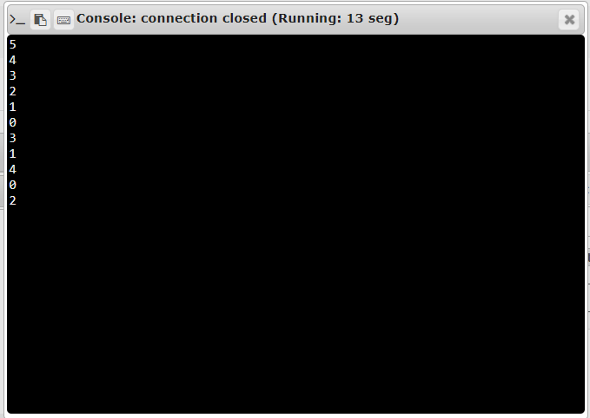

**RESULT:**

The Python program to remove and print every second number from a list of numbers until the list becomes empty is executed.